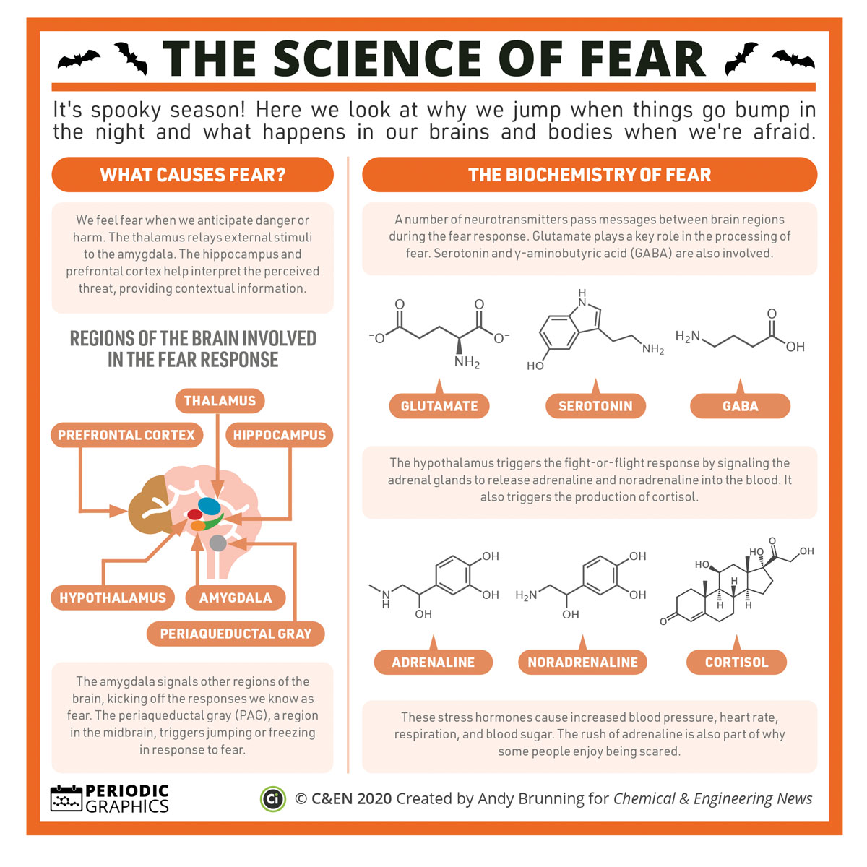
Cognitive
Here are some common signs and signals of a stress reaction:

confusion
nightmares
uncertainty
hypervigilance
suspiciousness
intrusive images
blaming someone
poor problem solving
poor abstract thinking
poor attention/ decisions
poor concentration/memory
disorientation of time, place
or person
difficulty identifying
objects or people
heightened or
lowered alertness
increased or decreased
awareness of
surroundings
etc...
Behavioral
How to defeat/defang FEAR - Isaiah 41:8–13

- Remember when God has _______ ______
Isaiah 41:8–9
8 But you, Israel, My servant, Jacob, whom I have chosen, descendant of Abraham, My friend — 9 I brought you from the ends of the earth and called you from its farthest corners. I said to you: You are My servant; I have chosen you and not rejected you.

- Remember God is ______________
Isaiah 41:10 (HCSB)
10 Do not fear, for I am with you; do not be afraid, for I am your God.
I will strengthen you; I will help you; I will hold on to you with My righteous right hand.

- Remember God’s _______________

Isaiah 41:13 (HCSB)
¹³ For I, Yahweh your God, hold your right hand and say to you: Do not fear, I will help you.

withdrawal
antisocial acts
inability to rest
intensified pacing
erratic movements
change in social
activity
change in speech
patterns
loss or increase of
appetite
hyper alert to
environment
increased alcohol
consumption
change in usual
communications
etc...
Emotional

fear
guilt
grief
panic
denial
anxiety
agitation
irritability
depression
intense anger
apprehension
emotional shock
emotional outbursts
feeling overwhelmed
loss of emotional
control
inappropriate emotional
response
etc...
Physical*

chills
thirst
fatigue
nausea
fainting
twitches
vomiting
dizziness
weakness
chest pain
headaches
elevated BP
rapid heart rate
muscle tremors
shock symptoms
grinding of teeth
visual difficulties
profuse sweating
difficulty breathing
etc...
Spiritual

anger at God
questioning of basic beliefs
withdrawal from place of worship
crisis of faith
faith practices and rituals seem empty
loss of meaning and purpose
uncharacteristic religious involvement
sense of isolation from God
anger at clergy
religious obsessions
religious compulsions
religious hallucinations or delusions
etc…

