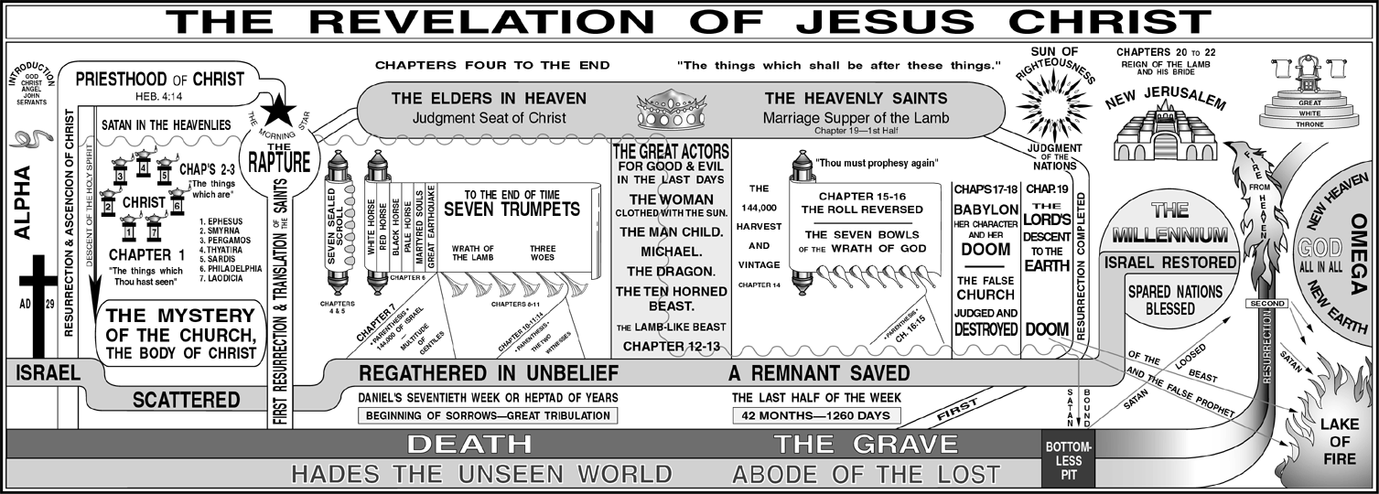

________________________________________________________________________________________________________________________________________________________________________________________________________________________________________________________________________________________________________________________________________________________________________________________________________________________________________________________________________________________________________________________________________________________________________________________________________________________________________________________________________________________________________________________________________________________________________________________________________________________________________________________________________________________________________________________________________________________________________________________________________________________________________________________________________________________________________________________________________________________________________________________________________________________________________________________________________________________________________________________________________________________________________________________________________________________________________________________________________________________________________________________________________________________________________________________________________________________________________________________________________________________________________________________________________________________________________________________________

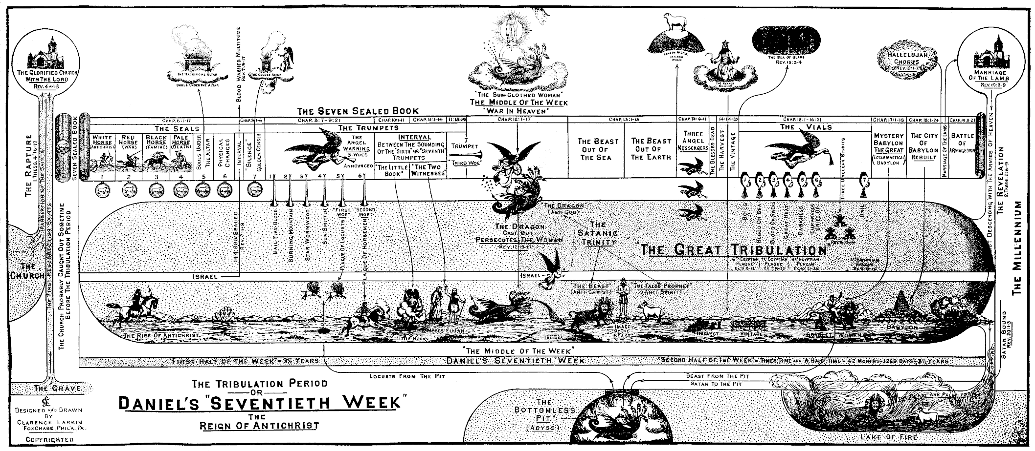
________________________________________________________________________________________________________________________________________________________________________________________________________________________________________________________________________________________________________________________________________________________________________________________________________________________________________________________________________________________________________________________________________________________________________________________________________________________________________________________________________________________________________________________________________________________________________________________________________________________________________________________________________________________________________________________________________________________________________________________________________________________________________________________________________________________________________________________________________________________________________________________________

Book of 61 11x17 charts can be purchased for $48 at https://www.larkinestate.com/books/charts.html

